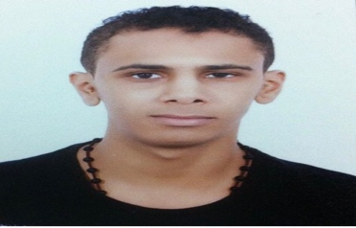Curriculum Vitae..

###### ALI HASAN AHMED ALAWI

Nationality: Bahraini

Cpr : 950308609

Date of Birth: Mar 30, 1995

Mobile:+973 33000873-

E-Mail: alihassan9549@gmail.com

# Objective:

To follow a career path leading to a challenging, demanding and satisfying career in a professional organization

##### ACADEMIC PROFILE

* *was studies* [B.Sc. in Physical Education](http://www.uob.edu.bh/en/index.php/colleges/college-of-pe-therapy/physical-education-departemt/133-ba-in-physical-education) at University Of Bahrain
* *Advance English in British Council*
* *High school diploma from sheikh Abdul-Aziz Secondary School*
* *Computer literate* in Windows XP, MS Word, MS Excel, MS Power Point and Internet

##### PROFESSIONAL PROFILE

* 2015 - Worked as Volunteers at Bilad Al Qadeem health centre

##### Languages

* Excellent command in Arabic and English

##### Other Skills

* Self-motivated, goal-driven, ambitious and diligent working
* Ability to work under pressure
* Ability to deal with different kinds of customers
* Time Management skills
* Ability to handle multiple projects/tasks
* Commitment, Observant

##### Interest

* Playing Football
* Learning and acquiring new skills in computer and all business fields
* Watching Movies

REFERENCES

Available upon request.